CENTRALIZED LOGGING WITH ELK

**1.Download elastic search, kibana and logstash and extract them.**

After downloading the elastic search,extraction then go in bin and run cmd and then the batch file.

1. **ELASTIC SERCH**

go to elastic search->bin and run the cmd and run elasticsearch.bat

elasticsearch.bat

now you can go and check if elastic search is running or not on localhost:9200

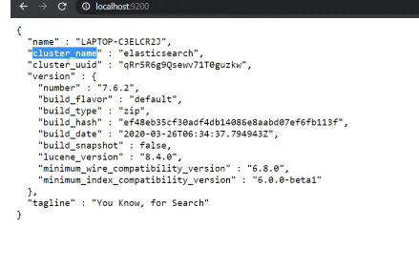

2.before starting kibana we need to tell kibana to look for the elasticsearch

Kibana->config->kibana.yml

We will uncomment the line

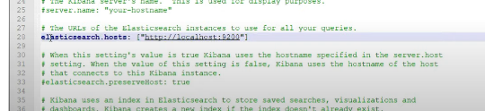

3.**KIBANA**

now go to kibana-> bin and run the batch file as

kibana.bat

kibana runs on localhost:5601

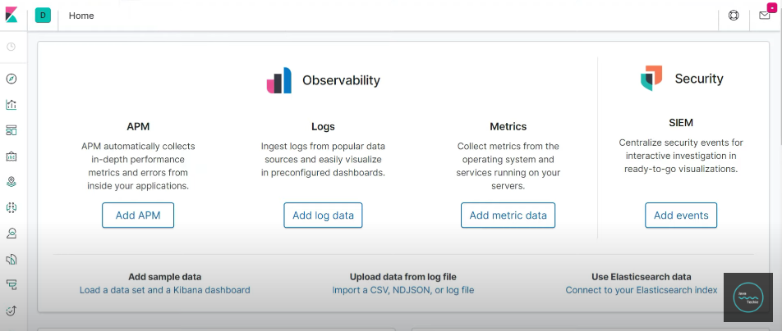

4. now we need to make a log file and give it to logstash

55.in application.properties we mention log file name and its path

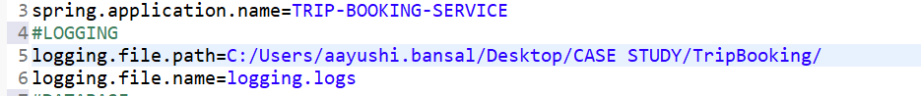

logging.file.path=C:/Users/aayushi.bansal/Desktop/CASE STUDY/TripBooking/

logging.file.name=logging.logs

6.now start your application and check if the logging file is being generated or not

7. **LOGSTASH**

First of all make a logstash.conf file

|  |
| --- |
| input{  file{  path =>"C:/Users/aayushi.bansal/Desktop/CASE STUDY/TripBooking/loggings.log"  }  }  output{  stdout{  codec=>rubydebug  }  elasticsearch{  hosts=>{"localhost:9200"}  }  } |

Put this logstash.conf file in the folder logstash->bin

* Now we need to run the below command
* A black screen with white text

  Description automatically generated

Now as a next step go to localhost:9200/_cat

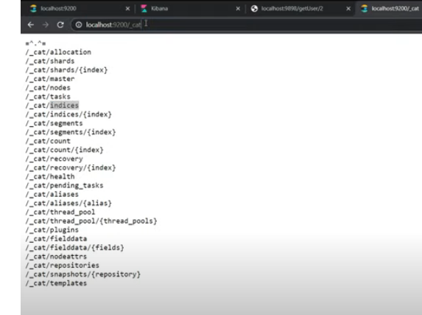

Here go to indices

These indices internally created by elk

Now copy the above content an dgiv in kibana console

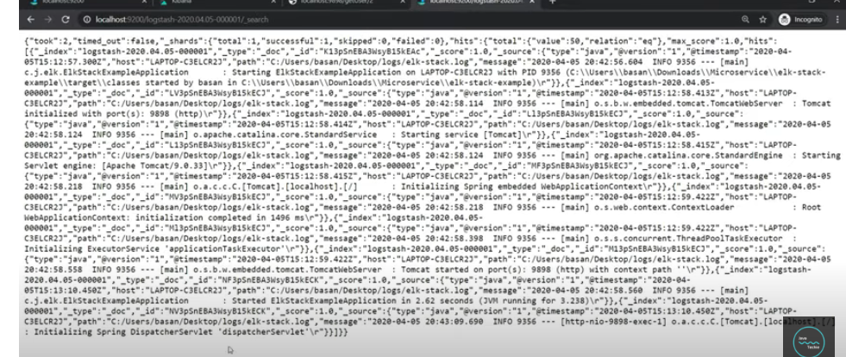

**KIBANA**

Go to kibana console->management

Create an index pattern

You will find your logstash

